1. MR program to find out total units sold out by each company

Java file for DRIVER class :



Java file for mapper class :



Java file for reducer class :



Execution and output :

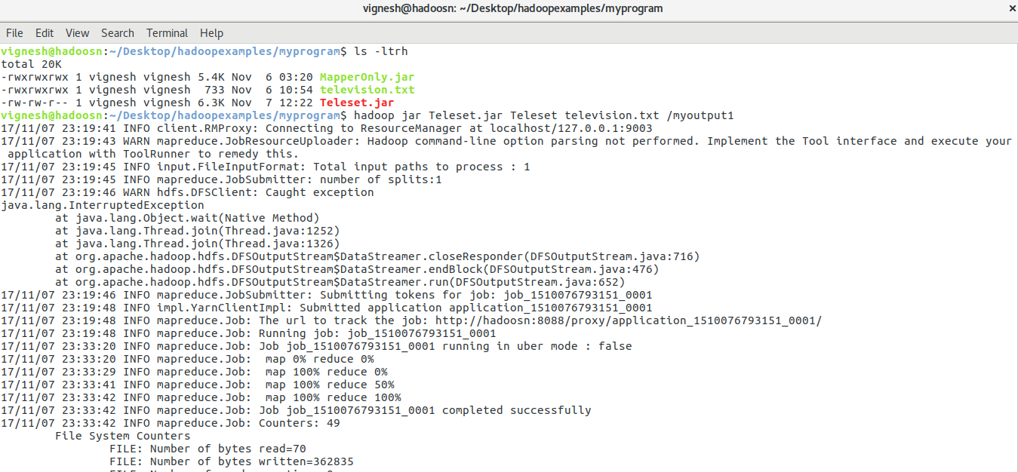

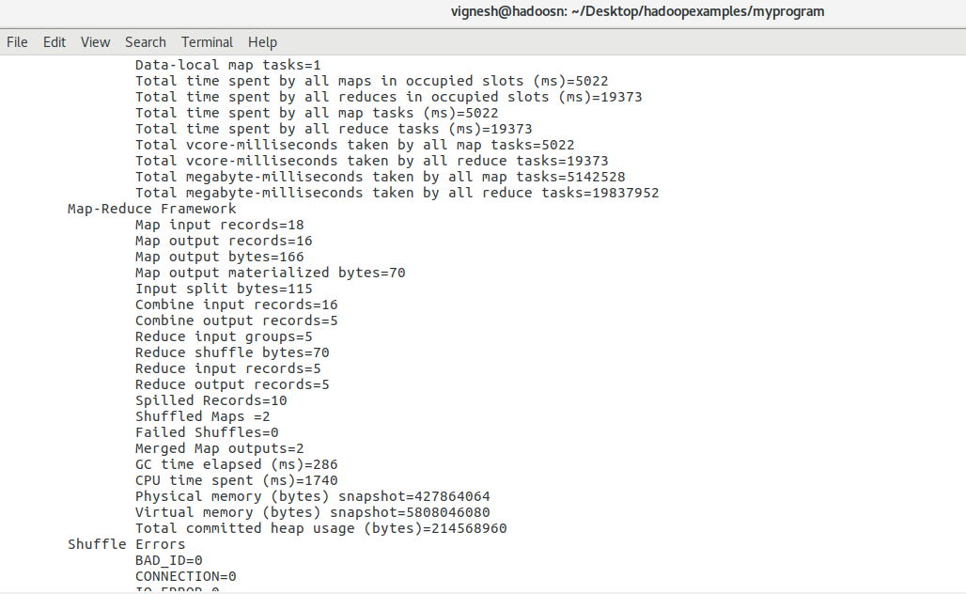

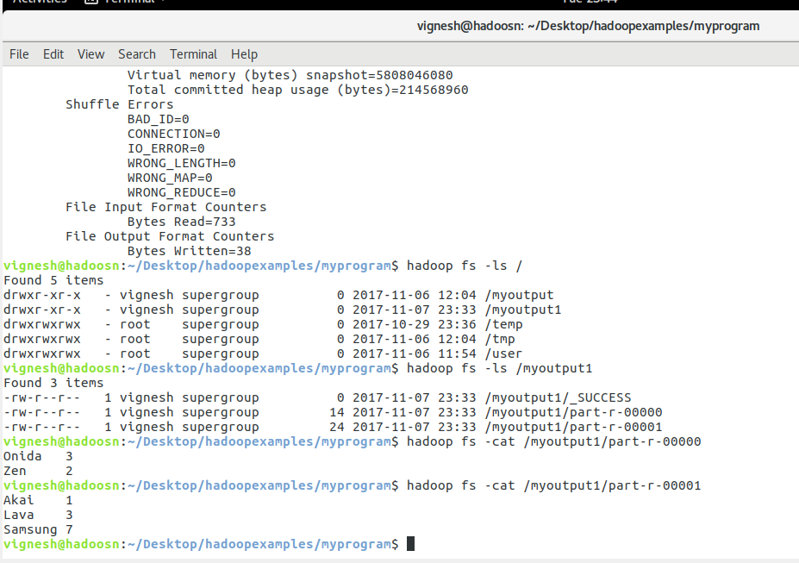

1. MP program to find out total units sold in each state

Driver code :



Mapper code :



Reducer code :



Execution and Output :

